# 1. Overview Data Science Project Pipeline

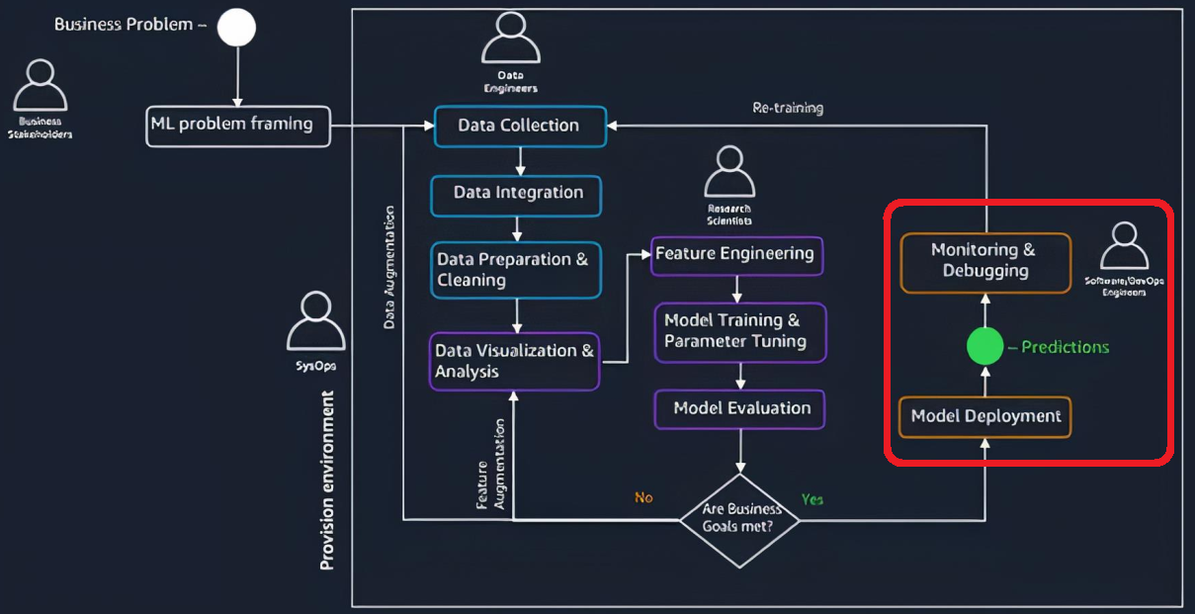

MLOps process will take roles at the end pipeline (marked by red circle).

* Model deployment
* Monitoring & Debugging

# 2. ML Model Serialization

## 2.1. Serialization and De-serialization

***Serialization*** (saving) is the process of translating a data structure (object) into a format that can be transmitted/ stored in a database or a file.

***De-serialization*** (loading) is the reverse process in which stored objects are loaded from a database or a file.

## 2.2. Pickle

A standard way of serializing objects in python *into format of byte stream*.

Pickle can be used for any object data type.

Often used to serialize machine learning algorithm and save it to a file.

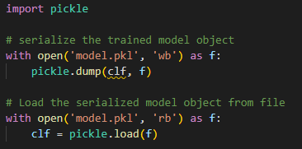

## 2.3. Joblib

Part of Scipy ecosystem and provides utilities for pipelining python jobs. Including saving and loading python objects into numerical data format such as numpy arrays.

Joblib only can used for numerical/ scientific computing data format such as numpy arrays, scikit-learn models.

Joblib is faster than pickle for serializing objects since able to use multi-core processors to perfom the operations in parallel.

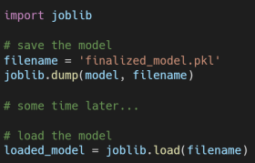

# 3. API & CRUD

API allows an application to communicate/ interact with other appications.

Four API methods most frequently used as below:

* Create
* Read
* Update
* Delete

Some of response code variations:

2xx 🡪 successfully done

3xx 🡪 redirection of the request

4xx 🡪 error from client-side

5xx 🡪 error from server-side

## 3.1. Flask

Lightweight python web application

It comes with built-in Werkzeug for the WSGI and Jinja2 for web templating.

As the documentation says, Werkzeug only ideal for development environment. Thus to deploy the API Flask to production environment need to use alternative WSGI such as gunicorn.

## 3.2. Postman

API development tool that allows developers to easily design, test, and document APIs.

The developers able to send request from Postman UI, and check the response.